PK-PROGRAM-TYPE-CODE (E1078) indicates the length of the Prekindergarten instructional day for a particular Prekindergarten student.

The PK-PROGRAM-TYPE-CODE captures the level of participation for a student in the PK program; half-day or full-day. The PK-PROGRAM-TYPE-CODE is a mandatory field for all PK students. Reference the Chart for Determining PK Funding Source below for additional information related to this data element.

For PEIMS Fall Submission (1), the PK-PROGRAM-TYPE-CODE is reported on the StudentSchoolAssociationExtension Complex Type.

Note that for PEIMS Summer Submission (3), the PK-PROGRAM-TYPE-CODE is reported on the BasicReportingPeriodAttendanceExtension Complex Type.

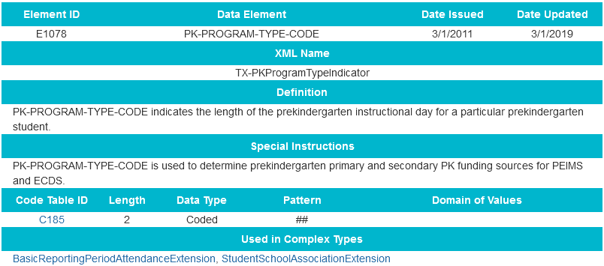
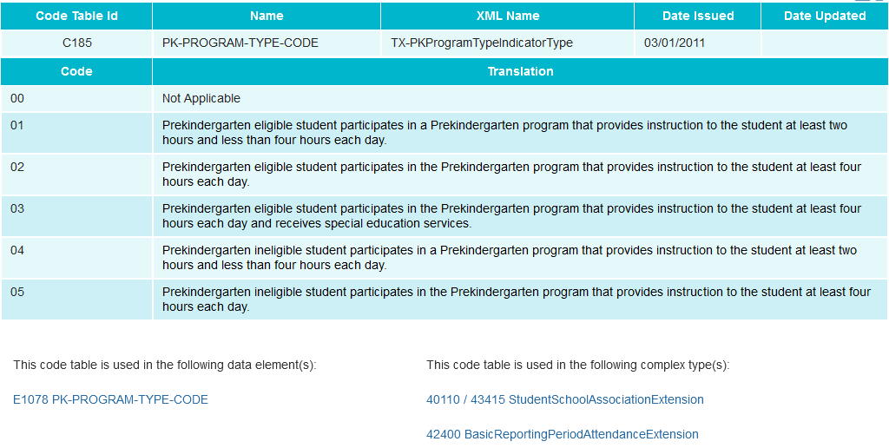
PRIMARY-PK-FUNDING-SOURCE (E1079) indicates the primary source of funding for a prekindergarten student.

The Primary PK Funding Source Code must be reported for:
- PK students who are Enrolled, Not in membership (ADA Eligibility Code 0),
- PK students who are eligible for half-day state funding but attend the PK program full-day, and
- PK students who are ineligible for state funding.
For example, if a student is eligible for PK, the TEA will pay for a half day of PK attendance. If the same student attends the PK program full day, then the LEA must at a minimum report a Primary Funding Source Code for that student to describe the source of funding that covers the expense of the PK program for the second half of the day.

SECONDARY-PK-FUNDING-SOURCE (E1080) indicates the secondary source of funding for a prekindergarten student.

The Secondary PK Funding Source Code may be reported for:
- PK students who are Enrolled, Not in membership (ADA Eligibility Code 0),
- PK students who are eligible for half-day state funding but attend the PK program full-day and have two funding sources for the second half of the day, and
- PK students who are ineligible for state funding and are funded through a secondary funding source in addition to the primary funding source.
For example, if a student is eligible for PK, the TEA will pay for a half day of PK attendance. If the same student attends the PK program full day, the second half of the day may be funded by two funding sources. If so, the LEA will report a Primary Funding Source Code and a Secondary Funding Source Code.

Primary and Secondary PK Funding Source Codes:

The Primary and Secondary PK funding Source Codes are only reported for prekindergarten students when a student is funded for half-day but attends full-day, or the PK student is ineligible for funding. See PEIMS code table C186. These students must have a Primary PK Funding Source Code and may have a Secondary PK Funding Source Code reported.

An eligible five year-old student in a Prekindergarten class must also be reported with a PARENT-REQUEST-RETENTION-INDICATOR (E1729).
